Essays remain an important method of assessment and enable examiners to discriminate between candidates, while also enabling candidates to display the skills and abilities which they possess.
As the essay paper has evolved it has become more demanding with much more emphasis on posing questions which allow candidates to display the higher order skills. Professor Roy Wilkinson of Sheffield University has identified a pyramid of skills which A level examinations try to test.
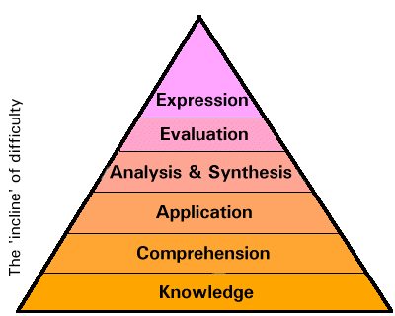

The pyramid of skills: the bottom two layers are 'Lower-order skills', while the top four layers are 'Higher-order skills'.

As there is now less emphasis on testing the lower order skills this implies that it is not possible for candidates to perform well in the essay paper by rote learning of notes.

Command words in essay titles
Examiners report that many candidates underperform because they fail to interpret the key words of an essay title. Below is a glossary of some of the most frequently used command words with suggestions for interpretation:
'Account for ...'
Explain how a particular event or situation came about i.e. 'Which factors would have led a large retailing company to...'
'Analyse ...'
Break down an argument or information into component parts and identify ways in which these parts are related. Always recognise the underlying assumptions.
'Analyse the extent to which ...'
Show judgement over the relevant importance of different arguments or events.
'Assess ...’
'Make some kind of judgement on the relative importance of a particular aspect of business studies, discussing the influence of other factors or events that influence the topic.
'Compare ...'
Describe two or more situations and show the difference and similarities between them.
'Criticise ...'
Present a view on a particular argument, point of view or theory, based on the evidence available.
'Define ...'
A simple statement is not enough. Use appropriate examples or formulae to illustrate and elaborate on your precise definition of a concept.
'Describe ...'
Usually more than a mere description is expected, instead a critical review of some particular set of circumstances or events is usually expected.
'Discuss ...'
Consider the arguments for and against the issue raised in the question.
'Distinguish ...'
Candidates need to show that they understand the differences between two (probably frequently confused) concepts. Similarities and differences need to be discussed and illustrated in distinguishing between the two concepts.
'Do ...' or 'Does ...'
Make a judgement on whether on set of circumstances is preferable to another.
'Evaluate ...'
Make reasoned judgements about the validity of a particular argument or statement, presenting evidence and reasoned argument of all relevant issues involved.
'Examine ...'
Candidates need to unravel the events that led to a particular set of circumstances or the validity of the reasoning that underlies a particular point of view. Stress the relative importance of the different arguments and their relevance to the basic issue under consideration.
'Explain ...'
Interpret the meaning of a particular concept with an example to illustrate understanding.
'Outline ...'
Only a brief description is required. Usually there are follow up parts to this question.
'To what extent ...'
This implies there is no definite answer to the question posed. Present both sides of the argument and exercise judgement by stressing the strength of some arguments over others.

How to improve your technique: some general principles

- Essays need a structure
  - jot down a simple plan
  - make sure you know where the essay is going before you start writing, i.e. your conclusion
- Essays must be a response to a specific title
  - avoid writing everything you know on a given topic, irrelevant material gains no marks
  - respond to the command words in the question
- Do not for get the essay title
  - refer back to the question regularly - probably at the end of every paragraph
  - every paragraph should answer the question set, aim for one theme per paragraph
- Avoid one-sided essays
  - usually the only questions that A level examiners will set are ones which can provoke differing viewpoints
  - always consider what your argument depends upon, i.e. the factors or assumptions inherent in your argument
- Demonstrate your depth of knowledge
  - analyse the question with care to show your understanding of the subject content
  - avoid paragraphs of textbook description
  - use appropriate graphs which must be accurate
  - use topical examples to back up your points
  - make references to other writers if appropriate
- Remember the higher order skills of analysis and evaluation
  - break down the material in a way that helps reveal the issues involved
  - use relevant business concepts to explore causes and effects
  - examine arguments critically
  - state which arguments you believe to be the most important and why
- Try to please the examiners!
  - use appropriate concepts and terminology
  - avoid slang e.g. 'The firm will go bust...'
  - be concise and relevant
  - leave enough time to write a conclusion

The essay plan - a suggested model
